**LAPORAN PRAKTIKUM**

**PERANCANGAN DAN PEMROGRAMAN WEB**

**MODUL 5**

**BOOTSTRAP**

Oleh:

Maulana Kaka Halin Widyadhana (2311104034)

**PROGRAM STUDI S1 REKAYASA PERANGKAT LUNAK**

**DIREKTORAT KAMPUS PURWOKERTO**

**UNIVERSITAS TELKOM**

**2025**

**BAB I**

**PENDAHULUAN**

* 1. **Dasar Teori**

Bootstrap merupakan sebuah front-end framework gratis untuk pengembangan antar muka web yang lebih cepat dan lebih mudah. Dikembangkan oleh Mark Otto dan Jacom Thornton di Twitter dan dirilis sebagai produk open source pada Agustus 2011 di GitHub. Bootstrap mencakup template desain berbasis HTML dan CSS untuk tipografi, form, button, navigasi, modal, image carousells dan masih banyak lagi, serta terdapat opsional plugin JavaScript. Selain itu, Bootstrap memiliki kemampuan untuk membuat desain responsif yang secara otomatis menyesuaikan diri agar terlihat baik di segala perangkat, mulai dari perangkat ponsel hingga desktop pc.

* 1. **Tujuan**

1. Mahasiswa mampu memahami konsep dan implementasi Bootstrap pada web. 2. Mahasiswa mengetahui jenis-jenis Bootstrap serta cara penggunaannya.

* 1. **Manfaat**

Mempermudah proses pembuatan web

**BAB II**

**HASIL PRAKTIKUM**

* 1. **Source Code**

**Index.html**

|  |
| --- |
| **<!DOCTYPE *html*>**  **<html *lang*="id">**  **<head>**  **<meta *charset*="UTF-8" />**  **<meta *name*="viewport" *content*="width=device-width, initial-scale=1.0"/>**  **<title>Toko Online</title>**  ***<!-- Link CSS Bootstrap (Sudah ada sebelumnya) -->***  **<link**  ***href*="https://cdn.jsdelivr.net/npm/bootstrap@5.3.3/dist/css/bootstrap.min.css"**  ***rel*="stylesheet"**  ***xintegrity*="sha384-QWTKZyjpPEjISv5WaRU9OFeRpok6YctnYmDr5pNlyT2bRjXh0JMhjY6hW+ALEwIH"**  ***crossorigin*="anonymous"**  **/>**  **<link *rel*="stylesheet" *href*="style.css" />**  **<style>**  ***.navbar-nav* *.nav-link* {**  **color: #a11b9c;**  **font-weight: bold;**  **margin-left: *15px*; */* Sedikit penyesuaian margin */***  **font-size: *16px*;**  **}**  ***.navbar-nav* *.nav-link:hover* {**  **text-decoration: underline;**  **color: #8a1786;**  **}**  ***/* Mengatur card agar mirip dengan .produk-item */***  ***.card-produk-custom* {**  **border-radius: *10px*;**  **border: *2px* solid #e5e5e5;**  **background-color: #fafafa;**  **transition: transform *0.2s* ease, box-shadow *0.2s* ease;**  **}**  ***.card-produk-custom:hover* {**  **transform: scale(*1.02*);**  **box-shadow: *0* *3px* *8px* rgba(*0*,*0*,*0*,*0.15*);**  **}**  ***.card-produk-custom* img {**  **border-top-left-radius: *8px*;**  **border-top-right-radius: *8px*;**  **object-fit: cover;**  **height: auto;**  **cursor: pointer;**  **}**  **</style>**  **</head>**  **<body>**  **<header>**  **<div *class*="Header-top">**  **<h1>Toko Online</h1>**  **</div>**  **<nav *class*="navbar navbar-expand-lg" *style*="background-color: white; border-bottom: 2px solid #e0e0e0;">**  **<div *class*="container-fluid justify-content-end">**  ***<!-- Tombol hamburger untuk mobile -->***  **<button *class*="navbar-toggler" *type*="button" *data-bs-toggle*="collapse" *data-bs-target*="#navbarNav" *aria-controls*="navbarNav" *aria-expanded*="false" *aria-label*="Toggle navigation">**  **<span *class*="navbar-toggler-icon"></span>**  **</button>**  ***<!-- Daftar menu -->***  **<div *class*="collapse navbar-collapse justify-content-end" *id*="navbarNav">**  **<ul *class*="navbar-nav">**  **<li *class*="nav-item">**  **<a *class*="nav-link" *href*="#">Beranda</a>**  **</li>**  **<li *class*="nav-item">**  **<a *class*="nav-link" *href*="#">Produk</a>**  **</li>**  **<li *class*="nav-item">**  **<a *class*="nav-link" *href*="#">Member</a>**  **</li>**  **<li *class*="nav-item">**  **<a *class*="nav-link" *href*="#">Login</a>**  **</li>**  **</ul>**  **</div>**  **</div>**  **</nav>**  ***<!-- Banner sebagai slideshow CSS-only (Tidak berubah) -->***  **<section *class*="banner">**  **<div *class*="slides">**  **<div *class*="slide">**  **<img *src*="assets/images/Header-Fashion-1.png" *alt*="Fashion 1" />**  **</div>**  **<div *class*="slide">**  **<img *src*="assets/images/Header-Fashion-2.png" *alt*="Fashion 2" />**  **</div>**  **<div *class*="slide">**  **<img *src*="assets/images/Header-Fashion-3.png" *alt*="Fashion 3" />**  **</div>**  **<div *class*="slide">**  **<img *src*="assets/images/Header-Fashion-4.png" *alt*="Fashion 4" />**  **</div>**  **</div>**  **<h2>Fashion Store</h2>**  **</section>**  **</header>**    **<main *class*="container mt-4">**  **<section *class*="produk-section">**  **<div *class*="produk-list">**    **<div *class*="card shadow-sm h-100 card-produk-custom">**  **<img *src*="assets/images/Baju-1.jpg" *class*="card-img-top" *alt*="Baju-1" *onclick*="detailIMG()">**  **<div *class*="card-body text-center pt-2">**  **<p *class*="nama-produk" *style*="margin-top: 10px;">Dan Heng Cosplay Costume</p>**  **<p *class*="harga">Rp 1.150.000</p>**  **</div>**  **</div>**  ***<!-- Popup detail gambar -->***  **<div *class*="detailGambar" *onclick*="sembunyikan()">**  **<img *src*="assets/images/Baju-1.jpg">**  **</div>**  ***<!-- Item produk lama (tetap menggunakan style.css) -->***  **<div *class*="produk-item">**  **<img *src*="assets/images/Baju-2.jpg" *alt*="Baju-2" />**  **<p *class*="nama-produk">Saber Cosplay Costume</p>**  **<p *class*="harga">Rp 1.350.000</p>**  **</div>**    **<div *class*="produk-item">**  **<img *src*="assets/images/Baju-3.jpg" *alt*="Baju-3" />**  **<p *class*="nama-produk">Blade Cosplay Costume</p>**  **<p *class*="harga">Rp 980.000</p>**  **</div>**  **<div *class*="produk-item">**  **<img *src*="assets/images/Baju-4.jpg" *alt*="Baju-4" />**  **<p *class*="nama-produk">Mambo</p>**  **<p *class*="harga">Rp 450.000</p>**  **</div>**  **<div *class*="produk-item">**  **<img *src*="assets/images/Baju-5.jpg" *alt*="Baju-5" />**  **<p *class*="nama-produk">Kitasan Ireng</p>**  **<p *class*="harga">Rp 500.000</p>**  **</div>**  **<div *class*="produk-item">**  **<img *src*="assets/images/Baju-6.jpeg" *alt*="Baju-6" />**  **<p *class*="nama-produk">Ryo</p>**  **<p *class*="harga">Rp 455.000</p>**  **</div>**  **<div *class*="produk-item">**  **<img *src*="assets/images/Baju-7.jpg" *alt*="Baju-7" />**  **<p *class*="nama-produk">Orvefre</p>**  **<p *class*="harga">Rp 750.000</p>**  **</div>**  **<div *class*="produk-item">**  **<img *src*="assets/images/Baju-8.jpg" *alt*="Baju-8" />**  **<p *class*="nama-produk">Bakushin Bakushin Bakushin</p>**  **<p *class*="harga">Rp 560.000</p>**  **</div>**  **</div>**  **<aside *class*="rekomendasi">**  **<h3>Rekomendasi</h3>**  **<img *src*="assets/images/Baju-9.webp" *alt*="Baju-9" />**  **<p *class*="nama-produk">Phainon Cosplay Costume</p>**  **<p *class*="harga">Rp 1.750.000</p>**  **</aside>**  **</section>**  **</main>**  **<footer>**  **<div *class*="footer-container">**  **<div *class*="footer-col">**  **<h4>FREQUENLY ASKED QUESTION</h4>**  **<ul>**  **<li>How to buy</li>**  **<li>Payment</li>**  **</ul>**  **</div>**  **<div *class*="footer-col">**  **<h4>CATEGORIES</h4>**  **<ul>**  **<li>Celana Pria</li>**  **<li>Sepatu Pria</li>**  **</ul>**  **</div>**  **<div *class*="footer-col">**  **<h4>FOLLOW US</h4>**  **<ul>**  **<li>Facebook</li>**  **<li>Twitter</li>**  **</ul>**  **</div>**  **</div>**  **</footer>**    **<script *src*="https://cdnjs.cloudflare.com/ajax/libs/jquery/3.7.1/jquery.min.js"></script>**    ***<!-- BARU: Script Bootstrap JS Bundle (diperlukan untuk komponen interaktif) -->***  **<script**  ***src*="https://cdn.jsdelivr.net/npm/bootstrap@5.3.3/dist/js/bootstrap.bundle.min.js"**  ***xintegrity*="sha384-YvpcrYf0tY3lHB60NNkmXc5s9fDVZLESaAA55NDzOxhy9GkcIdslK1eN7N6jIeHz"**  ***crossorigin*="anonymous">**  **</script>**  **<style>**  ***.detailGambar* {**  **display: none;**  **position: fixed;**  **top: *0*; left: *0*;**  **width: *100%*; height: *100%*;**  **background-color: rgba(*0*,*0*,*0*,*0.8*);**  **justify-content: center;**  **align-items: center;**  **z-index: *1000*;**  **}**  **</style>**  **<script>**  ***// Fungsi untuk menampilkan gambar***  **function detailIMG(){**  ***// Menggunakan display 'flex' agar gambar bisa di tengah***  **$(".detailGambar").*css*("display", "flex");**  **}**  **function sembunyikan(){**  **$(".detailGambar").*hide*();**  **}**  **</script>**  **</body>**  **</html>** |

**Style.css**

|  |
| --- |
| ***/* reset dan dasar */***  **\* { box-sizing: border-box; }**  **body {**  **font-family: Arial, Helvetica, sans-serif;**  **margin: *0*;**  **background-color: #fff;**  **color: #333;**  **-webkit-font-smoothing:antialiased;**  **}**  ***/* HEADER ATAS */***  ***.Header-top* {**  **background-color: #a11b9c;**  **color: white;**  **display: flex;**  **justify-content: space-between;**  **align-items: center;**  **padding: *12px* *40px*;**  **}**  ***.Header-top* h1 { font-size: *24px*; margin: *0*; font-weight: bold; }**  ***/* NAV - STYLE INI TIDAK LAGI DIGUNAKAN, DIGANTI BOOTSTRAP NAVBAR */***  ***/\****  ***.main-nav {***  ***background-color: white;***  ***text-align: right;***  ***padding: 10px 40px;***  ***border-bottom: 2px solid #e0e0e0;***  ***}***  ***.main-nav a {***  ***color: #a11b9c;***  ***text-decoration: none;***  ***font-weight: bold;***  ***margin-left: 25px;***  ***font-size: 16px;***  ***}***  ***.main-nav a:hover { text-decoration: underline; }***  ***\*/***  ***/* =================***  ***BANNER (CSS SLIDESHOW)***  ***================= */***  ***.banner* {**  **position: relative;**  **overflow: hidden;**  **height: *50vh*;        */* responsive height */***  **min-height: *280px*;**  **}**  ***.banner* img {**  **width: *100%*;**  **height: *100%*;**  **object-fit: cover;**  ***/* Tambahan untuk tajam */***  **image-rendering: -webkit-optimize-contrast;**  **image-rendering: crisp-edges;**  **image-rendering: high-quality;**  **transform: translateZ(*0*);**  **filter: contrast(*110%*) saturate(*105%*);**  **}**  ***/* container slide sebagai flex row; lebar = jumlah slide * 100% */***  ***.slides* {**  **display: flex;**  **width: auto;**  **height: auto;**  **will-change: transform;**  **animation: slideshow *20s* infinite;**  **animation-timing-function: ease-in-out;**  **}**  ***/* Setiap slide mengambil 100% viewport banner */***  ***.slide* {**  **flex: *0* *0* *100%*;**  **height: *100%*;**    **}**  ***.slide* img {**  **width: *100%*;**  **height: *100%*;**  **object-fit: cover;**  **display: block;**  **}**  ***.slide* {**  **flex: *0* *0* *100%*;**  **height: *100%*;**  **background-size: cover;**  **background-position: center;**  **background-repeat: no-repeat;**  **}**  ***/* overlay judul */***  ***.banner* h2 {**  **position: absolute;**  **bottom: *10px*;**  **left: *50%*;**  **transform: translateX(*-50%*);**  **font-size: clamp(*20px*, *4vw*, *36px*);**  **font-weight: *700*;**  **color: #a11b9c;**  **background-color: rgba(*255*,*255*,*255*,*0.85*);**  **padding: *8px* *20px*;**  **border-radius: *8px*;**  **letter-spacing: *1px*;**  **}**  ***/* Keyframes: 4 slides preview & hold each slide for some time */***  ***@keyframes* slideshow {**  **0%   { transform: translateX(*0%*); }**  **20%  { transform: translateX(*0%*); }**  **25%  { transform: translateX(*-100%*); }**  **45%  { transform: translateX(*-100%*); }**  **50%  { transform: translateX(*-200%*); }**  **70%  { transform: translateX(*-200%*); }**  **75%  { transform: translateX(*-300%*); }**  **95%  { transform: translateX(*-300%*); }**  **100% { transform: translateX(*0%*); }**  **}**  ***/* =================***  ***BAGIAN PRODUK & SIDEBAR***  ***================= */***  ***.detailGambar* img {**  **max-width: *80%*;**  **max-height: *80%*;**  **border-radius: *10px*;**  **box-shadow: *0* *0* *20px* #000;**  **cursor: pointer;**  **}**  ***.produk-section* {**  **display: flex;**  **justify-content: space-between;**  **align-items: flex-start;**  **padding: *70px* *60px*;**  **gap: *40px*;**  **}**  ***/* Grid produk */***  ***.produk-list* {**  **display: grid;**  **grid-template-columns: repeat(*4*, *1fr*);**  **gap: *25px*;**  **width: *100%*;**  **}**  ***/* STYLE INI DIGUNAKAN UNTUK PRODUK LAIN,***  ***TAPI ITEM PERTAMA SEKARANG MENGGUNAKAN BOOTSTRAP CARD***  ***\*/***  ***.produk-item* {**  **text-align: center;**  **border: *2px* solid #e5e5e5;**  **border-radius: *10px*;**  **padding: *10px*;**  **background-color: #fafafa;**  **transition: transform *0.2s* ease, box-shadow *0.2s* ease;**  **}**  ***.produk-item:hover* {**  **transform: scale(*1.02*);**  **box-shadow: *0* *3px* *8px* rgba(*0*,*0*,*0*,*0.15*);**  **}**  ***.produk-item* img {**  **width: *100%*;**  **height: auto;**  **object-fit: cover;**  **border-radius: *8px*;**  **}**  ***.nama-produk* { margin-top: *20px*; font-weight: bold; color: #333; }**  ***.harga* { color: #a11b9c; font-weight: bold; font-size: *15px*; }**  ***/* rekomendasi (sidebar) */***  ***.rekomendasi* {**  **width: *23%*;**  **background: #fff;**  **border: *2px* solid #e5e5e5;**  **border-radius: *10px*;**  **padding: *15px*;**  **text-align: center;**  **box-shadow: *0* *2px* *5px* rgba(*0*,*0*,*0*,*0.1*);**  **}**  ***.rekomendasi* h3 { color: #a11b9c; margin-bottom: *15px*; font-size: *20px*; }**  ***.rekomendasi* img { width: *100%*; height: auto; border-radius: *8px*; margin-bottom: *10px*; }**  ***/* FOOTER */***  **footer {**  **background-color: #f2f2f2;**  **padding: *40px* *60px*;**  **margin-top: *40px*;**  **}**  ***.footer-container* { display: flex; justify-content: space-between; flex-wrap: wrap; gap: *20px*; }**  ***.footer-col* { width: *30%*; min-width: *180px*; }**  ***.footer-col* h4 { color: #a11b9c; margin-bottom: *10px*; font-size: *16px*; }**  ***/* ==============***  ***RESPONSIVE BREAKPOINTS***  ***============== */***  ***/* tablet - layar sedang */***  ***@media* (max-width: *1024px*) {**  ***.produk-section* { flex-direction: column; padding: *30px* *40px*; }**  ***.rekomendasi* { width: *100%*; max-width: *100%*; order: *-1*; }**  ***.produk-list* { grid-template-columns: repeat(*3*, *1fr*); width: *100%*; }**  **}**  ***/* small tablet / large phone */***  ***@media* (max-width: *768px*) {**  ***.slides* { width: *400%*; */* tetap 4 slides */* }**  ***.produk-list* { grid-template-columns: repeat(*2*, *1fr*); }**  ***.Header-top* { padding: *12px* *20px*; }**  ***/* Navigasi kustom tidak lagi digunakan */***  ***/\****  ***.main-nav { padding: 8px 20px; text-align: center; }***  ***.main-nav a { display: inline-block; margin: 8px 10px; font-size: 15px; }***  ***\*/***  ***.rekomendasi* { width: *100%*; margin-top: *20px*; order: *-1*;}**  **footer { padding: *30px* *20px*; }**    **}**  ***/* mobile */***  ***@media* (max-width: *480px*) {**  ***.banner* { height: *40vh*; min-height: *160px*; }**  ***.produk-list* { grid-template-columns: *1fr*; gap: *20px*; }**  ***.Header-top* { padding: *10px* *14px*; }**  ***/* Navigasi kustom tidak lagi digunakan */***  ***/\****  ***.main-nav { padding: 10px 14px; text-align: center; border-top: 1px solid #eee; }***  ***.main-nav a { display: inline-block; margin: 6px 8px; font-size: 14px; }***  ***\*/***  ***.footer-container* { flex-direction: column; }**  ***.footer-col* { width: *100%*; }**  ***.produk-section* { padding: *20px*; gap: *20px*; }**  ***.produk-item* img { height: *180px*; }**  ***.banner* h2 { bottom: *12px*; padding: *6px* *12px*; font-size: *18px*; }**  ***.rekomendasi* { width: *100%*; margin-top: *15px*; }**  **}** |

* 1. **Screenshot output**

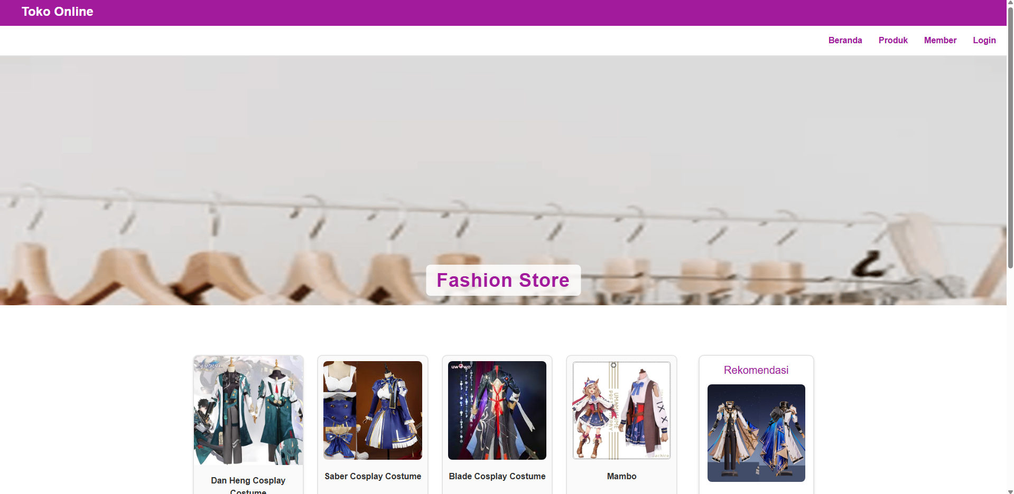

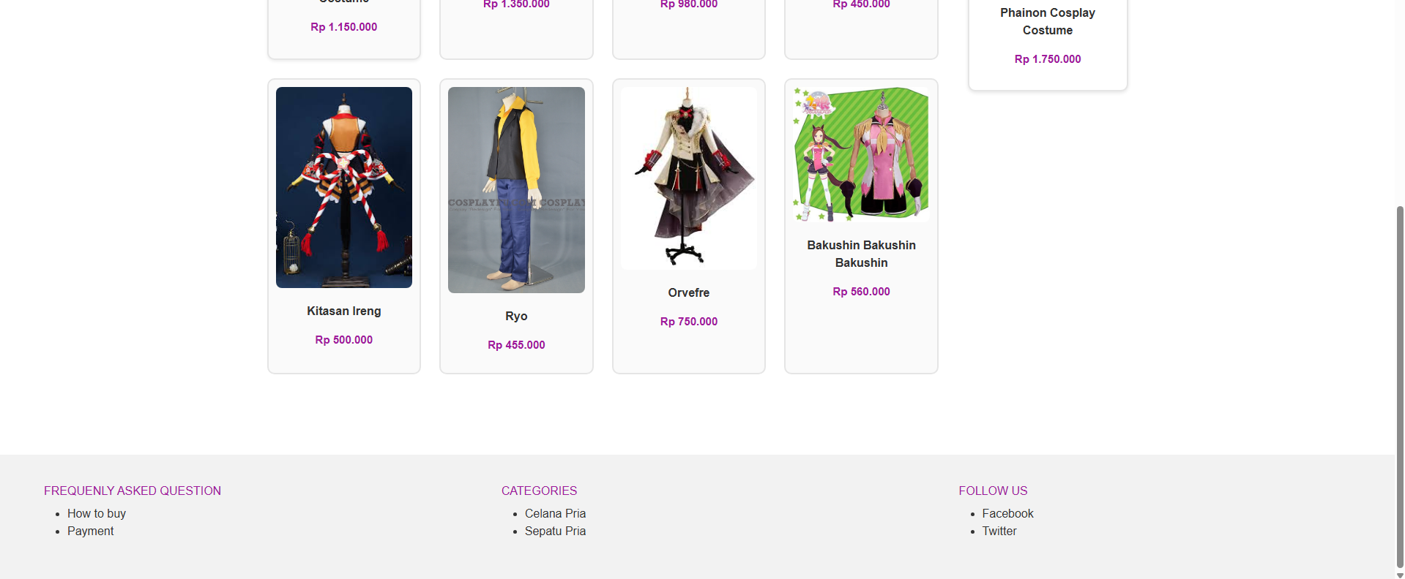

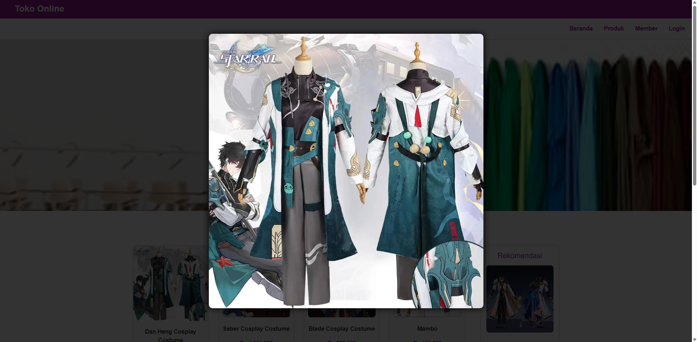

Komponen-komponen yang digunakan:

Bootstrap NavBar, Card, dan Container

**BAB III**

**KESIMPULAN & SARAN**

* 1. **Kesimpulan**

Bootstrap dapat membantu dalam melakukan pengembangan sebuah web dengan mempermudah proses pengerjaan karena beberapa komponen yang telah disediakan oleh bootstrap dapat diakses dengan mudah.

* 1. **Saran**

**-**